**Bluetooth Controlling Fan Of Arduino Programming.**



______________________________________

Project Proposal

By

H.M.S.R.Herath;

KAHDSE19.1f009;

**National Institute of Business Management,**

Kandy Regional Center,

No:02,

Asgiri Vihara Mawatha, Kandy.

Content

1. Introduction
2. Requirements
3. Method
4. Advantages & Disadvantages
5. Budget

1. INTRODUCTION

In the Present, popularity of controlling electrical device through phone has been increasing due to high performance and reduce work by connecting through Smartphone which is useful for elderly and physically disabled people, who can access and control the Appliances by staying at some place and access them remotely without the help of others.

It can control all micro components also. This communication between two devices by using Bluetooth is more reliable and securable.

Arduino System is used in this project to perform Bluetooth Controlling Fan.

1. REQUIREMENTS

* Arduino Uno Microcontroller 01
* HC 5 bluetooth Module 01
* Small Cooling Fan 01
* Project board 01
* Relay Level3.3v 01
* Batteries 02
* Wires & Cables 10

1. METHOD

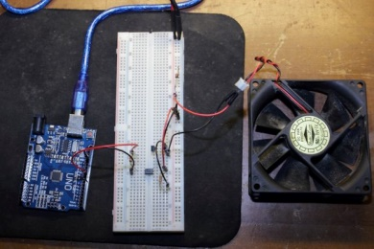

The Arduino software is programmed such that the fan. Bluetooth technology can link digital devices within a range of 10m to 100m at the speed of up to 3 Mbps depending on the Bluetooth device. This proposed technology is used to rotate the fan, and control the FAN using Bluetooth signal through Android mobile phone by using android application. DC current from dry batteries can be used as power source. But AC current also can be used through a AC/DC adapter.



1. ADVANTAGES & DISADVANTAGES

*Advantages*

* Easy to operate.
* Controlling can be done through a smart phone from a distance.
* Low cost.
* Reduce the risk.
* A light device.

*Disadvantages*

* Difficult to find the required Instruments and parts.
* Need a good Technical Knowledge.
* Device can be operate only one person (smart phone holder).

1. BUDGET

Item  *Price*

* Arduino Uno Microcontroller Rs 1400/=
* HC 5 bluetooth Module Rs 1100/=
* Small Cooling Fan Rs 400/=
* Project board Rs 850/=
* Relay Level3.3v Rs 450/=
* Batteries Rs 150/=
* Wires & Cables Rs 250/=

***Total Rs.4600/=***

**TITLE**

Project Title: *Bluetooth Controlling Fan Of Arduino Programming*

|  |  |  |
| --- | --- | --- |
| **Index No** | **Name** | **Signature** |
| KAHDSE19.1f009 | H.M.S.R.Herath |  |

Certified by:

* Name of the Supervisor : Mrs. Akila Wijethunghe
* Signature of the Supervisor : ……………………….
* Date of Submission : ……………………….